

MATHEMATICS
Specialist Units 3 & 4

Test 5 – Applications of Differentiation and Differential Equations

Chapters 12 and 16
Semester 2 2017

Section One – Calculator Free

Time allowed for this section
Working time for this section: 15 minutes
Marks available: 17 marks

Material required/recommended for this section

To be provided by the supervisor
This Question/Answer booklet
Formula sheet

To be provided by the candidate
Standard items: pens, pencils, pencil sharpener, eraser, correction fluid, ruler, highlighters

Special items: Nil

Important note to candidates

No other items may be used in this section of the examination. It is your responsibility to ensure that you do not have any unauthorised notes or other items of a non-personal nature in the examination room. If you have any unauthorised material with you, hand it to the supervisor before reading any further.

- (3 marks)
The equation of a curve is $y^{4}+x^{2}y^{2}=2a^{3}(x+2a)$, where a is a constant. Find the gradient of the curve at the point (3a, a).

- (3 marks)
Find the equation relating $x$ and $y$, given the differential equation $cosy\frac{dy}{dx}=2x+1$ and $y=\frac{π}{2}$ when $x=3$.

- (5 marks)
Consider the diagram provided below. is a chord of fixed length and Q can be located anywhere on the major arc AB, meaning will be constant no matter where exactly Q is.

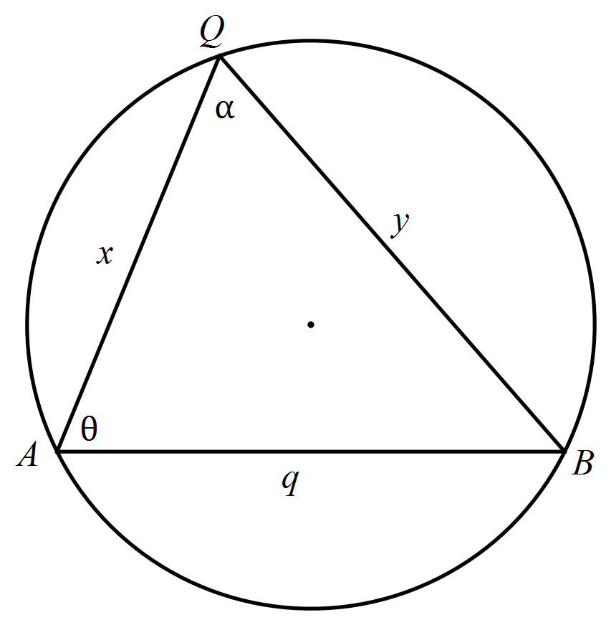

- Write an expression for q in terms of x, y and α. [1]

- Write an expression for $\frac{dy}{dx}$ in terms of x, y and α, remembering that q and α are constants. [2]

- Justify that y is a stationary point where $cosα=\frac{x}{y}$ [2]

- (6 marks)
The slope field for the differential equation $\frac{dy}{dx}=2(y+1)$ is shown below.

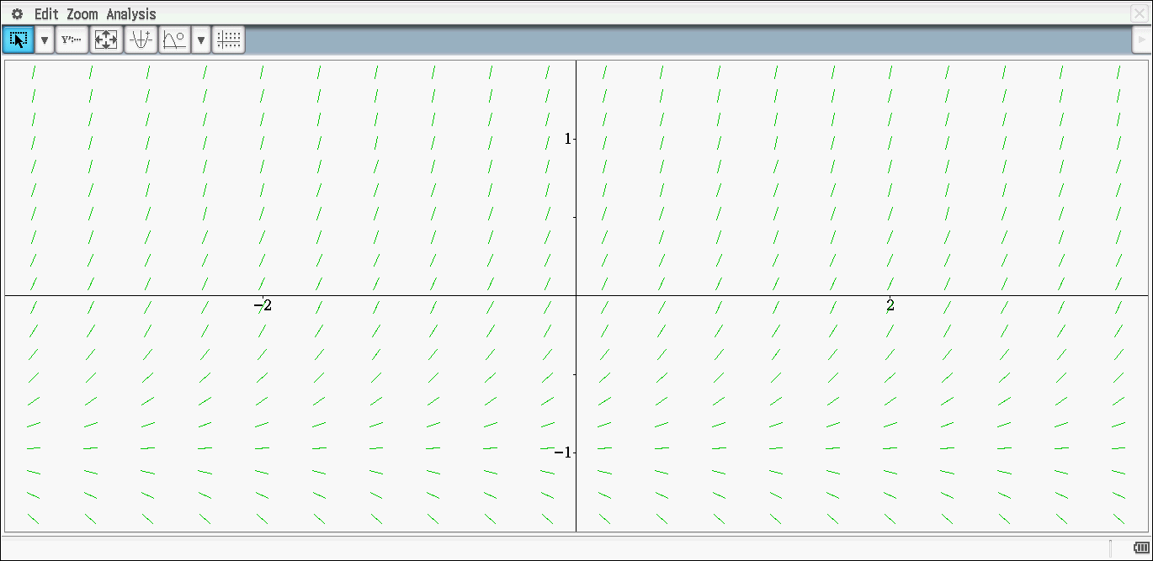

- Sketch the solution curve which passes through (0, 1). [2]

- Determine the equation of the solution curve drawn in part a. [4]

End of Section One
This page has intentionally been left blank
You may use this space to extend or re-attempt an answer to a question or questions and should you do so then number the question(s) attempted and cross out any previous unwanted working.

